

Πανεπιστήμιο Δυτικής Αττικής
Σχολή Μηχανικών
Τμήμα Μηχανικών Πληροφορικής και Υπολογιστών

Εργαστήριο Ανάλυσης
και σχεδιασμού
πληροφοριακών συστημάτων

ΝΙΚΟΛΑΟΣ ΘΩΜΑΣ
ΑΜ: 21390068
ΤΜΗΜΑ: ΧΠ

ΑΘΗΝΑ
Δευτέρα, 29 Ιανουαρίου 2024
Περιεχόμενα
B1: Use Cases 3
B2: Dataflow Diagram 4
B3: Data Models 4
B4: Database 5
B5: Activity Diagram 7

Μελέτη συστήματος οδοντιατρείου

B1: Use Cases

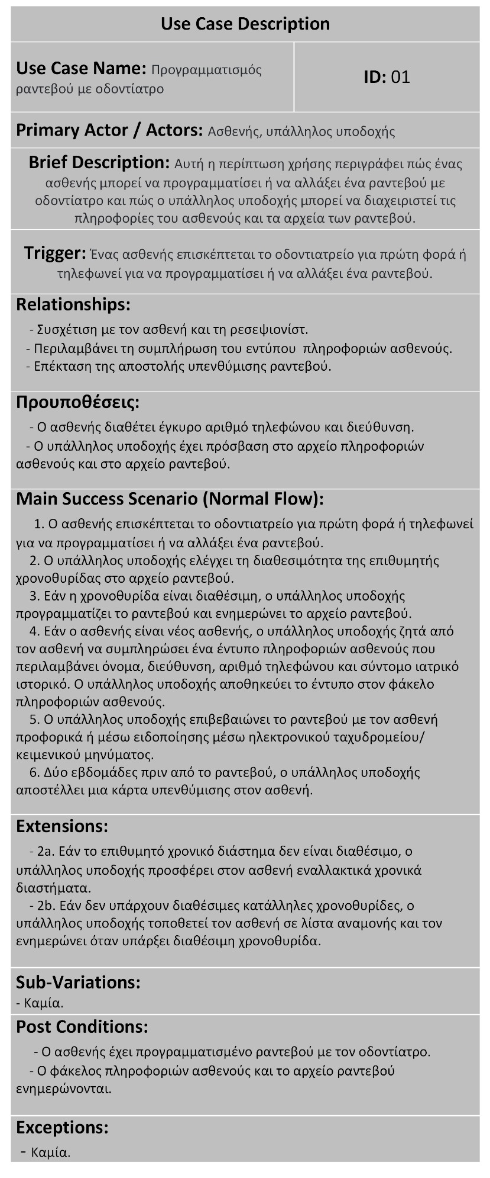

B2: Dataflow Diagram

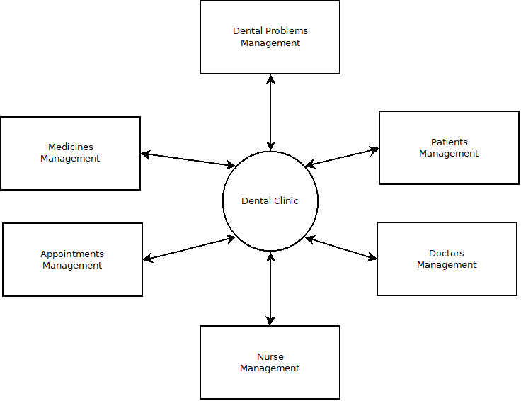

B3: Data Models

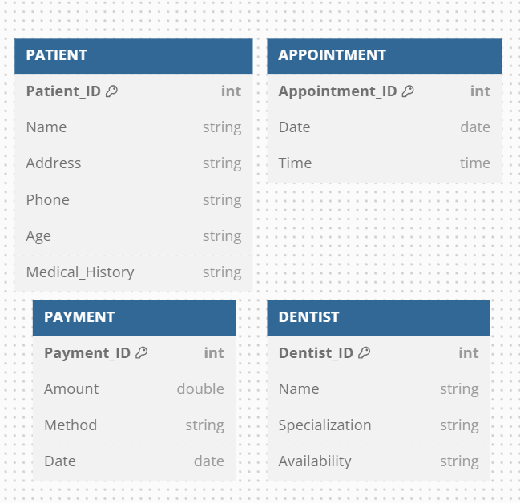
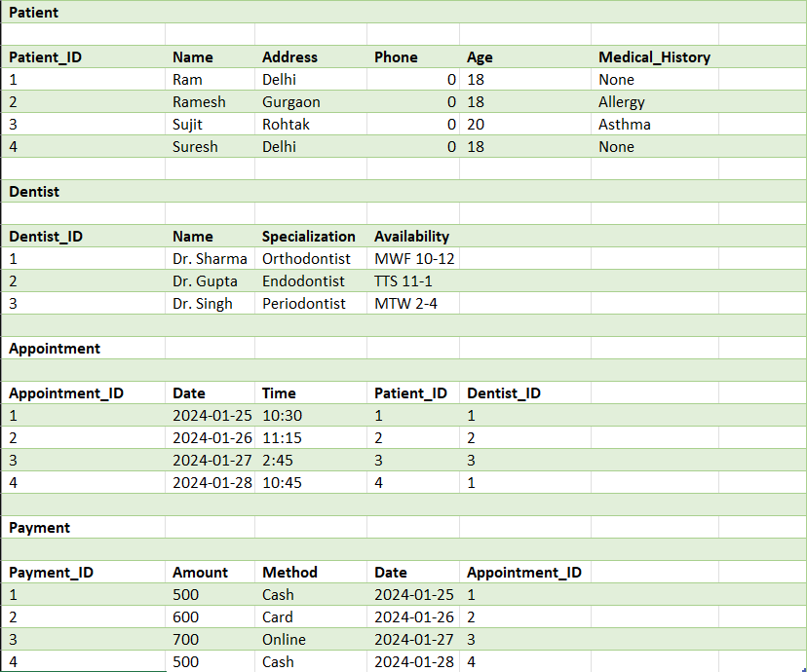

B4: Database

Sqlite

CREATE TABLE Patient (  Patient_ID INTEGER PRIMARY KEY,  Name TEXT,  Address TEXT,  Phone TEXT,  Age INTEGER,  Medical_History TEXT  ); | INSERT INTO Patient VALUES (1, 'Ram', 'Delhi', 0, 18, 'None');  INSERT INTO Patient VALUES (2, 'Ramesh', 'Gurgaon', 0, 18, 'Allergy');  INSERT INTO Patient VALUES (3, 'Sujit', 'Rohtak', 0, 20, 'Asthma');  INSERT INTO Patient VALUES (4, 'Suresh', 'Delhi', 0, 18, 'None');
CREATE TABLE Dentist (  Dentist_ID INTEGER PRIMARY KEY,  Name TEXT,  Specialization TEXT,  Availability TEXT  ); | INSERT INTO Dentist VALUES (1, 'Dr. Sharma', 'Orthodontist', 'MWF 10-12');  INSERT INTO Dentist VALUES (2, 'Dr. Gupta', 'Endodontist', 'TTS 11-1');  INSERT INTO Dentist VALUES (3, 'Dr. Singh', 'Periodontist', 'MTW 2-4');
CREATE TABLE Appointment (  Appointment_ID INTEGER PRIMARY KEY,  Date TEXT,  Time TEXT,  Patient_ID INTEGER,  Dentist_ID INTEGER,  FOREIGN KEY (Patient_ID) REFERENCES Patient(Patient_ID),  FOREIGN KEY (Dentist_ID) REFERENCES Dentist(Dentist_ID)  ); | INSERT INTO Appointment VALUES (1, '2024-01-25', '10:30', 1, 1);  INSERT INTO Appointment VALUES (2, '2024-01-26', '11:15', 2, 2);  INSERT INTO Appointment VALUES (3, '2024-01-27', '2:45', 3, 3);  INSERT INTO Appointment VALUES (4, '2024-01-28', '10:45', 4, 1);
CREATE TABLE Payment (  Payment_ID INTEGER PRIMARY KEY,  Amount INTEGER,  Method TEXT,  Date TEXT,  Appointment_ID INTEGER,  FOREIGN KEY (Appointment_ID) REFERENCES Appointment(Appointment_ID)  ); | INSERT INTO Payment VALUES (1, 500, 'Cash', '2024-01-25', 1);  INSERT INTO Payment VALUES (2, 600, 'Card', '2024-01-26', 2);  INSERT INTO Payment VALUES (3, 700, 'Online', '2024-01-27', 3);  INSERT INTO Payment VALUES (4, 500, 'Cash', '2024-01-28', 4);

Δοκιμή της βάσης:

SELECT Patient.Name, Appointment.Date, Appointment.Time
FROM Patient
JOIN Appointment ON Patient.Patient_ID = Appointment.Patient_ID;

Αποτέλεσμα:
- Name: Patient's name.
- Date: Date of the appointment.
- Time: Time of the appointment.

SELECT SUM(Amount) AS TotalCash
FROM Payment
WHERE Method = 'Cash';

Αποτέλεσμα:
- TotalCash: The total amount of cash payments.

B5: Activity Diagram

